Name:
Bungee Candy
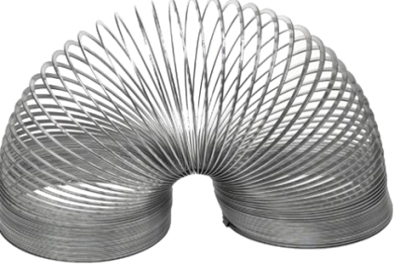
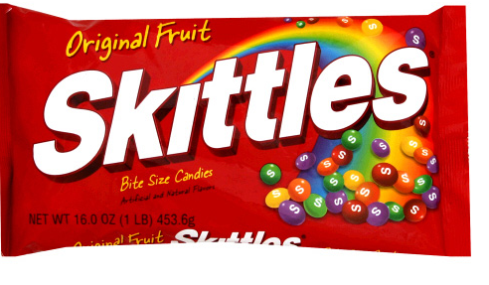

Goal: Students will collect data and model their finding in a graph and compare results with others in the class.
Objectives:
- Given supplies, the students will find the distance of the cup from the floor with a certain amount of skittles in the cup
- The students will then graph their findings on a scatter plot.
- Students will apply their knowledge of collecting data and interpreting data information.
Vocabulary:
- Positive Correlation: If the x-coordinates and the y-coordinates both increase
- Negative Correlation: If the x-coordinates and the y-coordinates have one increasing and one decreasing
- No Correlation: if there seems to be no pattern, and the points looked scattered.
- Trend line: A line on a graph showing the general direction that a group of points seem to be heading

Materials:
-Slinky - Two yard sticks
-Two paper clips - A paper cup
-Skittles in a bag - Worksheets

Set Up:
Give each group a bag of skittles.
Set up classroom with meter sticks in place for the students
Have the cups attached with the Slinkys.
Procedure:
Step 1: Students place one Skittle into the cup. Once skittles is placed, wait for the slinky to stop moving then measure the distance from the floor with the other yard stick.
Step 2: Students will collect data and write down their data on a result sheet. Students will keep adding Skittles one at a time until the cup touches the floor.
Step 3: Students will then make a table of their results that they have collected.
Step 4: Students will then make a scatter plot with the points they have collected. (X axis is number of Skittles and Y axis is inches from the floor.)
Step 5: Using a straight edge students will be able to see a line of regression.
Step 6: Using the Scatter plot graph, have the students analyze their data and write down what they have noticed will doing this experiment. (What are they noticing?)
Other Questions:
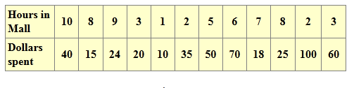
- Prepare a scatter plot for the following. Determine from your graph whether there is a correlation between the numbers of hours spent in a mall and the numbers of dollars spent.

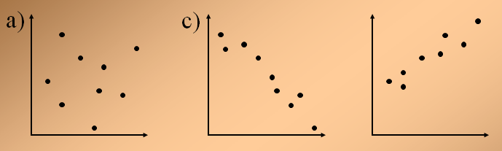
- Show trend lines, Determine if it’s Positive, Negative or No Correlation.

Connections:
1. Where else would you use this application in the real world?
2. What are some factors that would affect this
experiment?

Adaptions:
Calculus
- http://danielwalsh.tumblr.com/post/11566016253/explaining-an-astonishing-slinky
Physics
- http://slinky.org/
References:
- http://www.ehow.com/info_8416141_handson-secondary-math-activities.html
- www.lemars.k12.ia.us/webfiles/ccollins/Prealgebra/.../Scatterplots[1].ppt

